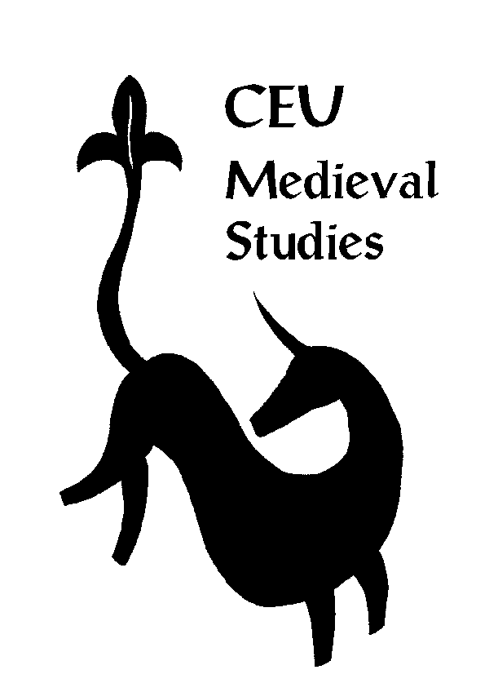
Medieval Studies Department, CEU Budapest
Language Skills Form

As part of the admission procedure, the Medieval Studies Department requires that the applicants fill in this Language Skill Form.

You do not have to mark all languages but can include as many others not appearing on the form as you wish.

Source languages (basic, good, excellent):

 | Reading | Writing
Ancient Greek
Latin
Old Church Slavonic
Ottoman Turkish

Modern languages (basic, good, excellent):

 | Reading | Writing | Speaking
French
German
Italian
Spanish

The information provided is NOT intended as a device to determine whose applications will be successful. It is, rather, designed to serve as an assessment of your language skills, so that we may both help students arrange their language classes for the year and propose a modification of the research topic in case applicants need to improve their language skills. Therefore, in addition to the general CEU admission requirements applicants are expected to prove that they have a basic knowledge of the languages of medieval sources.

