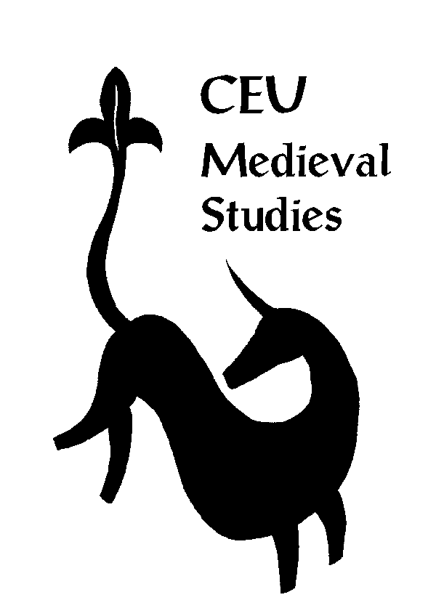
Medieval Studies Department, CEU Budapest
Language Skills Form

As part of the admission procedure, the Medieval Studies Department requires that the applicants fill in this Language Skill Form.

You do not have to mark all languages but can include as many others not appearing on the form as you wish.

Source languages (basic, good, excellent):

 | Reading | Writing
Ancient Greek
Latin
Old Church Slavonic
Ottoman Turkish

Modern languages (basic, good, excellent):

 | Reading | Writing | Speaking
French
German
Italian
Spanish

The Medieval Studies Department may require that the applicants take a source language aptitude test. The language test selection is very much dependent on the thesis proposal and the candidate’s future interest. Therefore, the language in which the applicant is tested is up to the Selection Committee’s discretion.

The test is NOT intended as a device to determine whose applications will be successful. It is, rather, designed to serve as an assessment of the applicants’ language skills, so that we may both help students arrange their language classes for the year and propose a modification of the research topic in case applicants need to improve their language skills.

Those applicants who will have to take a language aptitude test, a few weeks after the application deadline, will receive information about the testing directly from the Medieval Studies Department.

